**Name : Adwait S Purao**

**UID : 2021300101**

**Batch : B2**

**Experiment no. : 1**

**Aim :** To understand, use and interpret **Network Utilities** (its **commands** & the general significance of the Internet)

**What is the Internet?**

• **The internet is a vast network of interconnected devices** such as computers, smartphones, servers, routers, and more that are connected through a web of cables, wireless signals, and satellites.

• These devices use standardized communication protocols, such as **TCP/IP**, to transmit and receive data, allowing them to connect and share information with each other seamlessly.

• The internet enables a wide range of activities, including sending and receiving emails, browsing the web, streaming videos, making online purchases, and much more.

• The **World Wide Web (WWW)** is a system of interlinked hypertext documents accessed via the internet. It allows users to access and share information, resources, and services using **web browsers** such as Chrome or Firefox

• The internet has had a profound impact on society and has become an essential tool for communication, education, commerce, and entertainment.

● **What is computer newtork ?**

An interconnection of multiple devices, also known as

hosts, that are connected using multiple paths for the

purpose of sending/receiving data or media. Computer

networks can also include multiple devices/mediums

which help in the communication between two different

devices; these are known as **Network devices** and

include things such as routers, switches, hubs, and

bridges.

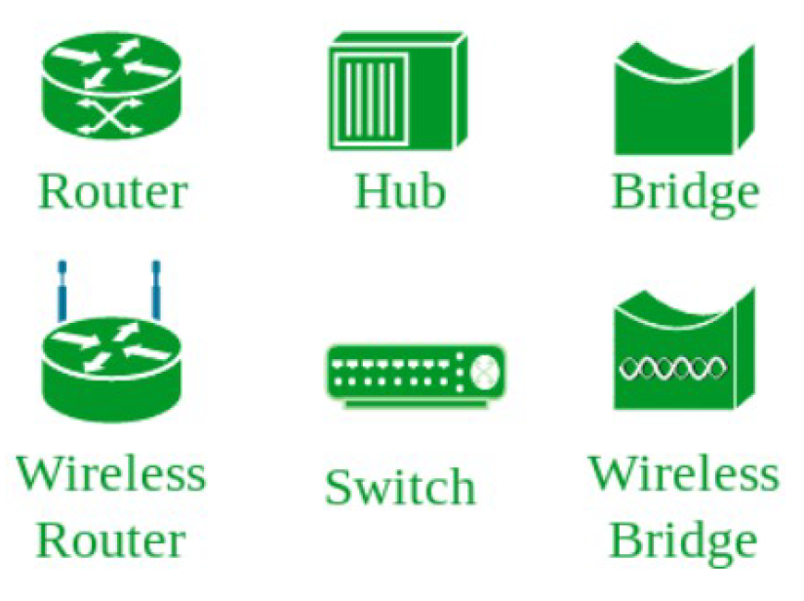

● **Why is it needed ?**

1. Resource sharing: Networks allow users to access shared resources such as printers, storage devices, and applications from any connected device.
2. Communication: Networks enable communication between users through email, instant messaging, video conferencing, and other forms of communication.
3. Data sharing: Networks allow for the sharing of information and data between users and systems, making it easier to collaborate on projects and share knowledge.
4. Remote access: Networks allow users to access their files and applications from remote locations, enabling telecommuting and remote work.
5. Scalability: Networks allow for the easy expansion of resources and the integration of new devices, making it possible to add more users and devices to the network as needed.

Overall, computer networks provide the foundation for efficient and effective communication, collaboration, and information sharing in today's digital world.

● **History of Computer Networking**

● The history of modern computer networking technology goes

back to 1969, when ARPANET (Advanced Research Projects Agency

Network) became the first connected computer network. It

implemented the TCP/IP protocol suite, which later became the

Internet.

● ARPANET was developed by the Advanced Research Projects

Agency (ARPA), a subset of the US Department of Defense. Why did

the DoD need to develop networked computers? The Cold War, of

course! The goal of ARPANET was to keep lines of communication

open if the USA and the USSR decided to exchange nuclear devices.

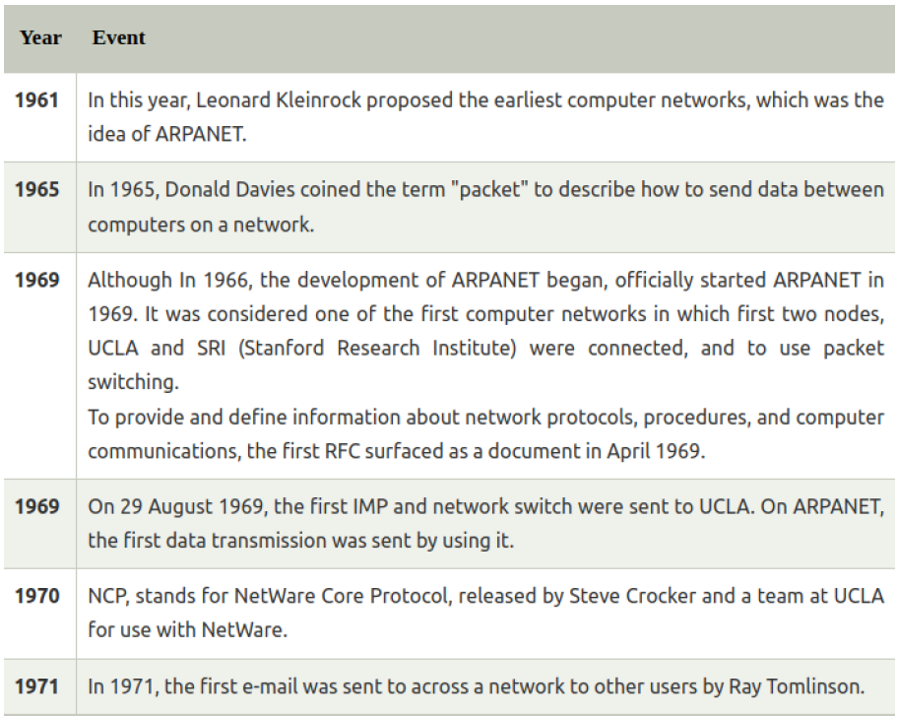

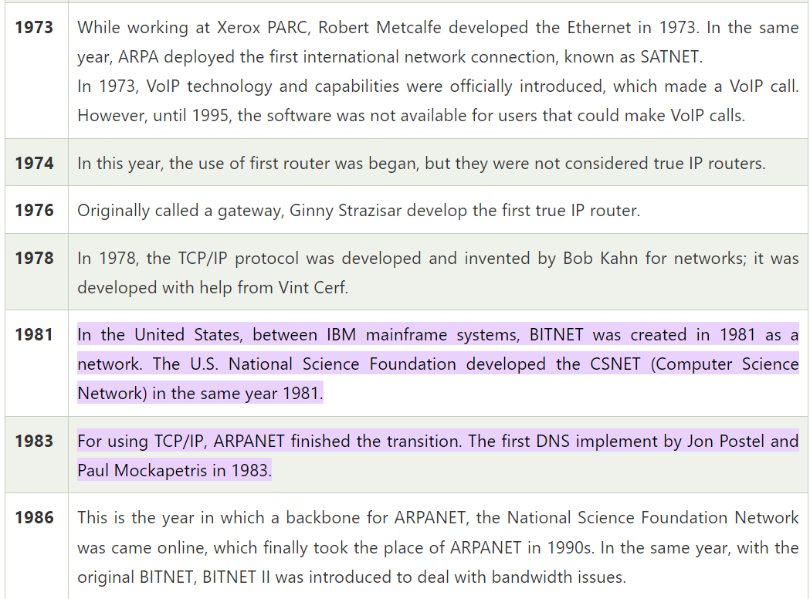

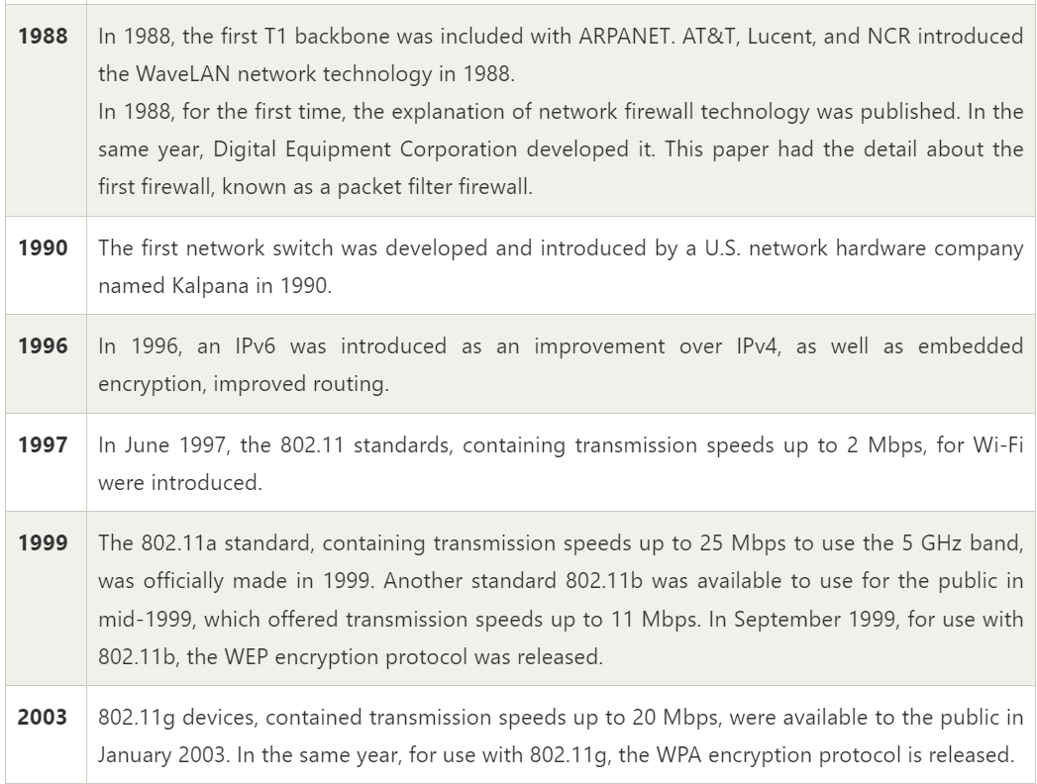

**Commands on Linux :**

1. **Ifconfig**

You can use the **ifconfig** command to assign an address to a network interface and to configure or display the current network interface configuration information. The **ifconfig** command must be used at system startup to define the network address of each interface present on a system. After system startup, it can also be used to redefine an interfaces address and its other operating parameters. The network interface configuration is held on the running system and must be reset at each system restart. The **ifconfig** command interprets the **IFF_MULTICAST** flag and prints its value if it is set.

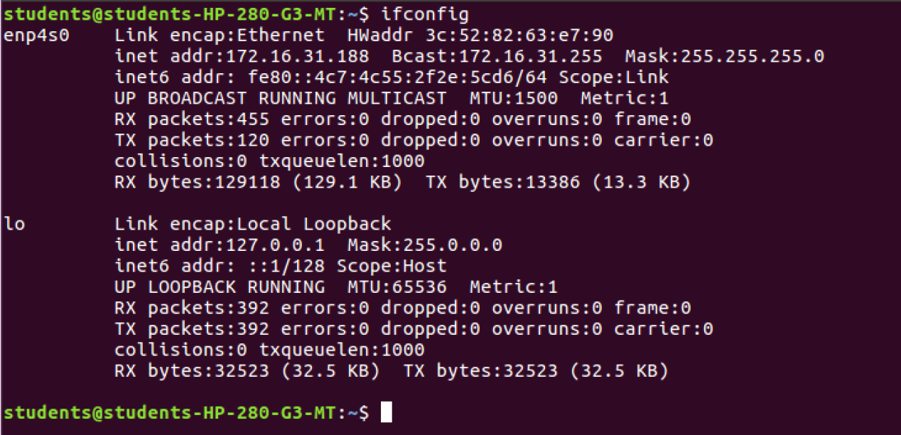

1. **What is ping**

**Ping** is short for **Packet Internet Groper**. This command is mainly used for checking the network connectivity among host/server and host. The ping command takes the URL or IP address as input and transfers the data packet to a specified address along with a **"PING"** message. Then, it will get a reply from the host/server. This time is known as **"latency"**.

**Note: Low latency and fast ping means faster connection.**

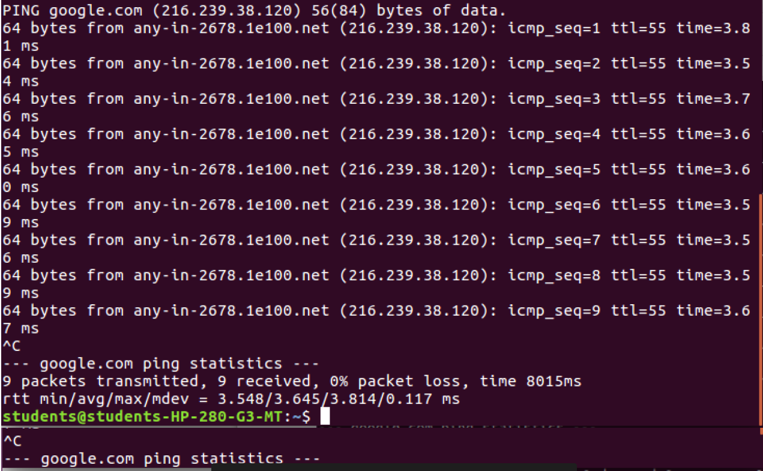

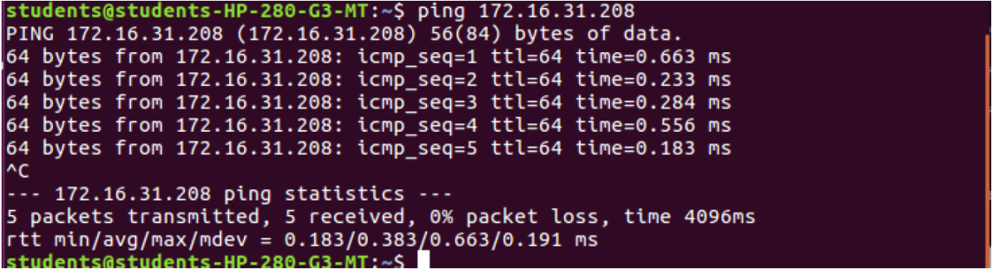

1. **What is IP Address ?**

An IP address is a unique address that identifies a device on the internet or a local network. IP stands for "Internet Protocol," which is the set of rules governing the format of data sent via the internet or local network.

In essence, IP addresses are the identifier that allows information to be sent between devices on a network: they contain location information and make devices accessible for communication. The internet needs a way to differentiate between different computers, routers, and websites. IP addresses provide a way of doing so and form an essential part of how the internet works.

1. **Nslookup Command**

Name server lookup (nslookup) is a command-line tool that lets you find the internet protocol (IP) address or domain name system (DNS) record of a specific hostname. This command also allows reverse DNS lookup by inputting the IP addresses of the corresponding domains.

The nslookup tool is useful for DNS-related tasks, such as server testing or troubleshooting issues. To use this tool, type “nslookup” into a command-line interface (CLI) such as the Command Prompt on Windows or Terminal on Linux and macOS.

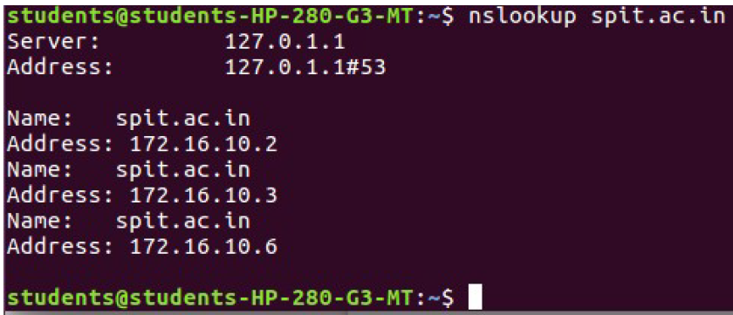

1. **Traceroute**

Linux traceroute command is a network troubleshooting utility that helps us determine the number of hops and packets traveling path required to reach a destination. It is used to display how the data transmitted from a local machine to a remote machine. Loading a web page is one of the common examples of the traceroute. A web page loading transfers data through a network and routers. The traceroute can display the routes, IP addresses, and hostnames of routers over a network. It can be useful for diagnosing network issues.

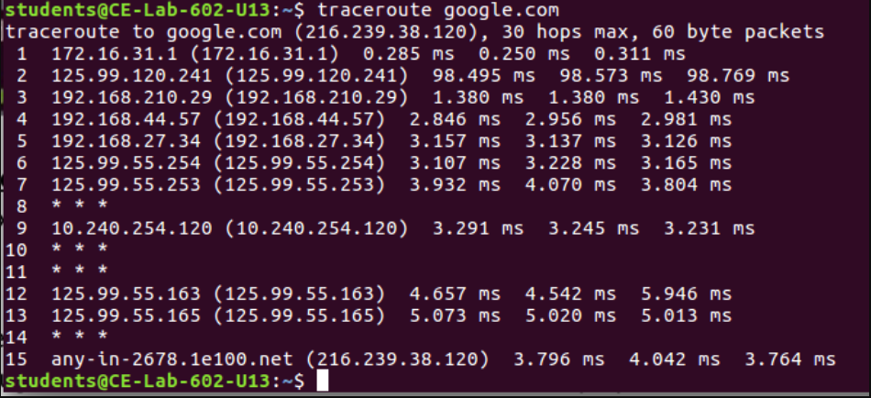

1. **Sudo apt-get install**

sudo apt-get install command is used to download the latest version of your desired application from an online software repository pointed to by your sources.list configuration file and and install that application on your Linux machine.

A good analogy is to think of your computer as a factory and the apt-get command as the manager in that factory who is responsible for the installation of new equipment, removal of equipment that is no longer needed, and update desired equipment to their latest versions, while maintaining records of the equipment names and versions which are currently present in the factory.

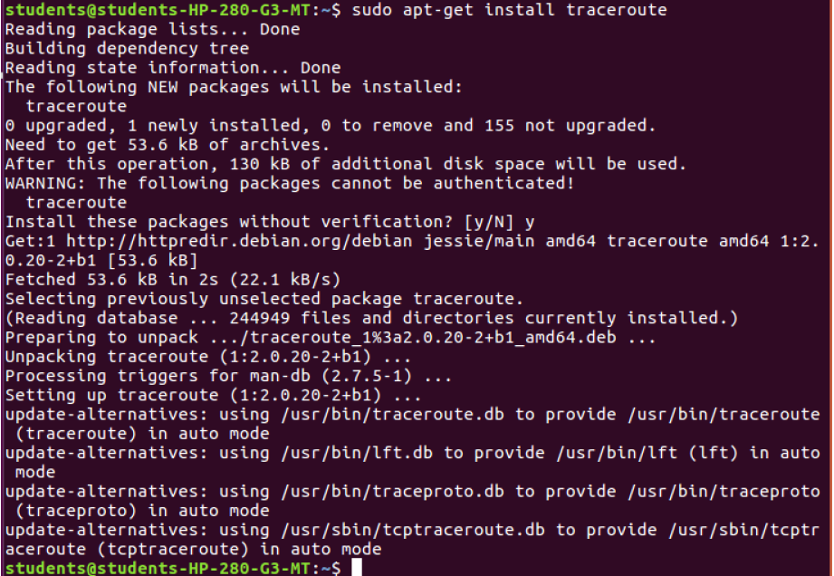

1. **ARP command**

The arp stands for the “Address Resolution Protocol” and it makes changes in the kernel’s table which contains the arp addresses.

The arp command allows users to manipulate the neighbor cache or ARP table. It is contained in the Net-tools package along with many other notable networking commands (such as ifconfig). The arp command has since been replaced by the ip neighbour command**.**

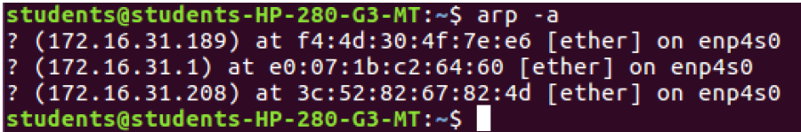

1. **IPCONFIG:**

network_command_ipconfig

The IPCONFIG network command provides a comprehensive view of

information regarding the IP address configuration of the device we are

currently working on.

The IPConfig command also provides us with some variation in the primary

command that targets specific system settings or data, which are:

IPConfig/all - Provides primary output with additional information about

network adapters.

IPConfig/renew - Used to renew the system’s IP address.

IPConfig/release - Removes the system’s current IP address.

1. **HOSTNAME:**

network_command_hostname

The HOSTNAME command displays the hostname of the system. The

hostname command is much easier to use than going into the system

settings to search for it.

Command to enter in Prompt – hostname

**Conclusion:**

In short, network utilities and its commands are helpful tools for managing and improving my network. I can use them to quickly find and fix problems with my network.

We also learnt about the history of computer network and implemented the various commands in command prompt.